**PC Lab for L3.8 – L3.13**

**In this exercise, we will create various plottings via Seaborn based on the “Iris” dataset.**

import seaborn as sns

sns.set()

iris = sns.load_dataset("iris")

iris.head()

**Exercise 1** (Scatter plot) Create a scatter plot between ‘petal_length’ and ‘petal_width’.

**Exercise 2** (Joint Plot)

1. Create a joint plot between ‘sepal_length’ and ‘sepal_width’.
2. Create a joint plot between ‘sepal_length’ and ‘sepal-width’ stratified by ‘species’.

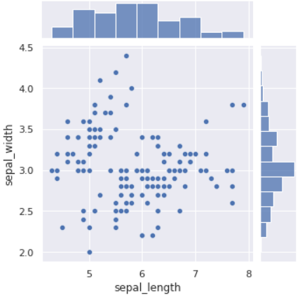

**Exercise 3** (Box plot) Create a box plot for ‘sepal-length’ for different ‘species’ in the same figure.

**Exercise 4** (Violin plot)

1. Create a violin plot for ‘sepal-length’ for different ‘species’ in the same figure.
2. Show the violin and box plots together for ‘sepal-length’ for different ‘species’ in the same figure.

**Exercise 5** (Pair plot) Create the pair plot.

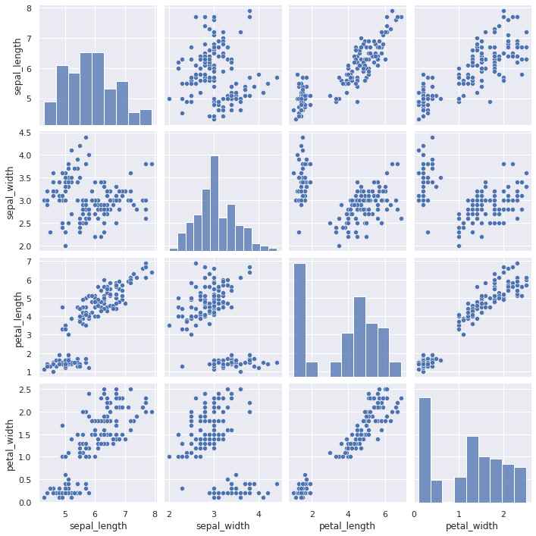

**Exercise 6** (Histogram) Create histograms for all variables.

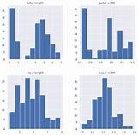

Solutions:

1.

a. sns.scatterplot(x="petal_length", y="petal_width", data=iris)

b. sns.scatterplot(x="petal_length", y="petal_width", data=iris, hue= 'species')

2.

a. sns.jointplot(x="sepal_length", y="sepal_width", data=iris, height=5)

b. sns.jointplot(x="sepal_length", y="sepal_width", data=iris, hue= 'species', height=5)

3.

sns.boxplot(x="species", y="sepal_length", data=iris)

4.

a. sns.violinplot(x="species", y="sepal_length", data=iris)

b. sns.violinplot(x="species", y="sepal_length", data=iris)

sns.boxplot(x="species", y="sepal_length", data=iris)

5.

sns.pairplot(iris)

6.

iris.hist(edgecolor='white', linewidth=0.25)

plt.gcf().set_size_inches(12,8)

plt.show()